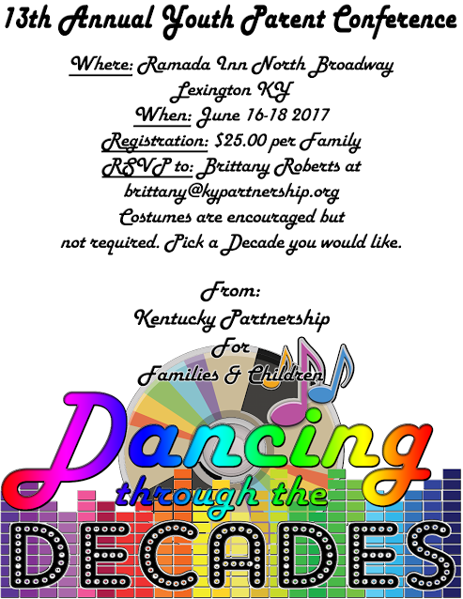
1-800-369-0533 Kentucky Partnership for Families and Children, Inc.

KPFC’s Thirteenth Annual Youth/Parent Conference

Youth Track 13-16 Years Old
- Know’s Ball
- Adventure Based Therapy
- Silencing stigma with the sound of music
- Self-Image and feeling good about yourself
- Art Therapy
- Kentucky Youth Move Panel
Young Adult Track 17-25 Years Old
⇒ Know’s Ball
⇒ Adventure Based Therapy
⇒ Kentucky Youth Move Panel
⇒ Self-Image and feeling good about yourself
⇒ Art Therapy
⇒ Silencing stigma with the sound of music
Parent Track
- Art Therapy
- Leadership
- Surviving Crisis
- Substance Abuse
- Adventure Based Therapy
- Boundaries

Conference Schedule
Friday, June 16  3-5:30pm Registration  6-7pm Dinner and Welcome 7-8:00pm Session #1 8:00pm Adjourn  11:00pm CURFEW  Saturday, June 17 Breakfast starts at 7:00 am Eat before 9:00 a.m.!  Sessions start at 9:00 a.m.! | Saturday, June 17  9:00 -10:00 am Session #2  10:00—10:20 am Break  10:20—11:20 am Session #3  11:20-11:40 am Break  11:40-12:40 pm Session #4  12:40--1:40 pm Lunch  1:40—2:40 pm Session #5  2:40—3:00 pm Break  3:00—4:00 pm. Session #6  4:00 - 6:00 pm Break  6:00—7:00 pm Dinner  8:00-11:00pm Dance  11:00pm CURFEW | Sunday, June 18  9—11:30am Session #6  11:30—12:00pm Closing 12:00 pm Adjourn  Have a Safe Trip Home

Who should attend the conference?
- Youth between the ages of 13-17 years old that have an emotional, behavioral, mental health, and/or substance use disability.
- Young Adults (transitional age: 18-25 years old) that have an emotional, behavioral, mental health, and/or substance use disability.
- Parents of these youth and young adults.
- IMPORTANT: ALL youth under the age of 18, or who are over 18 but have a guardian, must have a parent/guardian that will attend the conference with them!
- CHILDREN UN DER THE AGE OF 13 CANNO T ATTEN D THE CO NFERENCE SESSIO NS. If you bring young- er children with you, you must have your own child care for them during the conference sessions. NO Exceptions!! Parents, c hildren cannot attend sessions with you!
- Child Care Options:

Find family member or friend to babysit younger children in your home community.
  - Find family member or friend to babysit younger children in your hotel room.
  - One spouse can attend the conference while the other spouse watches younger children at home or in hotel room.
Registration Fee Information:
- Again this year, we are requesting a $25 regi stration f ee per family. An additional $25 fee is requested per lodging rooms needed. If you can’t afford this, please contact the KPFC office at bri ttany@kypartnership.org to inquire about assistance.
- Registration Refunds: Registration fee will be refunded if cancellation request is made by 4pm, Monday, June 5, 2017. After June 5, 2017 no refunds will be given.
For qu estions abo ut th e c onferenc e pleas e c ontact:
Brittany at 502-875-1320 ext.12 or at brittany@kypartnership.org
**Registration is available online this year at kypartnership.org as well as paying your registration fee through PayPal for your convenience. You can still register online and mail you registration fee, please be aware, you will not receive a confirmation letter until your registration fee has been received.**
Conference Sponsors

1-800-369-0533 Kentucky Partnership for Families and Children, Inc.

Please complete the entire conference registration.
Registrations will be processed on a first come, first served basis.

Track Attending

- Youth Name:_
Age
13-16_
17-Young Adult

- Youth Name:_

Age
13-16_
17-Young Adult

- Youth Name:_

Age
13-16_
17-Young Adult

- Youth Name:_
Age
13-16_
17-Young Adult

- Parent/Guardian’s Name:_
- Parent/Guardian’s Name:_
Address
Phone Number:_
- Will you be bringing children under age 13?
Email Address

Registration forms and
$25 registration fee must be received by May 30, 2017!

- If yes what childcare arrangements have you made?
- Total number attending from your family:_
- Are there any dietary restrictions we should be made aware of as we prepare meals?
- Ethnicity: ☐Hispanic ☐Latino ☐Neither
- Race: ☐White ☐Black or African American ☐Native Hawaiian or Other Pacific ☐Asian ☐American Indian or Alaskan Native
- Child's disability: _______________________________________

Youth Participation Parent/Guardian of Youth Participants
Please read the contract below and sign Please read the contract below and sign prior to attending the conference prior to attending the conference

- Attend the workshops while at the conference
- Do my best to control my behavior
- Let other youth or staff know if I need something to help me better cope with my disability
- Show respect to my parents, other youth and their parents, the staff, and presenters
- Allow KPFC to take and use my picture for newsletters, reports, and other publicity activities
- Have fun while at the conference!
- To follow the 11pm curfew set by KPFC
- Attend the workshops while at the conference
- Show respect to my child, other youth and their parents, the staff, and presenters
- Allow KPFC to take and use my picture and my children’s picture for newsletters, reports, and other publicity activities
- Ensure that any children I bring under the age 13 will have proper supervision during sessions
- Supervise my children (any age) when not in session
- Have fun while at the conference!
- To follow the 11pm curfew set by KPFC

- Youth Signature Date

**I understand that KPFC shall not be held liable for any behavioral difficulties my child may experience while at the conference.**

- Youth Signature Date

- Youth Signature Date
1. Parent/Guardian Signature Date

4. Youth Signature Date

2. Parent/Guardian Signature Date

